## Why a Template for Audit Analysis?

In the past we did a lot of Audits on different kind of Project related matters.

We used all kind of documents, from PDF to Excel sheet and everything in between.

After we had filled in those documents, we took time to analyze the outcome and then created a final report.

It should be much easier to use a template that you could change to the parts you want to Audit.

On an afternoon I have created this Excel Sheet that will help you to analyze the information that you will gather during the Audit.

The sheet is not protected and I have put no copyright on it, does not make any sense anyway because with all the tooling that exist someone could easily crack the passwords and then change it to their requirements.

## Various Tabs

There are a number of tabs that you can use, these are the following

* Parameters - Here you can fill in all the parameters that will automatically change the content of the sheets
* Info - Here you can some hands-on information aboit the sheet
* 1 - Sheet to be filled in based upon the parameters
* 2 - Sheet to be filled in based upon the parameters
* 3 - Sheet to be filled in based upon the parameters
* 4 - Sheet to be filled in based upon the parameters
* 5 - Sheet to be filled in based upon the parameters
* 6 - Sheet to be filled in based upon the parameters
* 7 - Sheet to be filled in based upon the parameters
* 8 - Sheet to be filled in based upon the parameters
* 9 - Sheet to be filled in based upon the parameters
* 10 - Sheet to be filled in based upon the parameters
* Analysis - Analysis after everything is filled in

## How does it work?

In the parameter sheet you will see the following

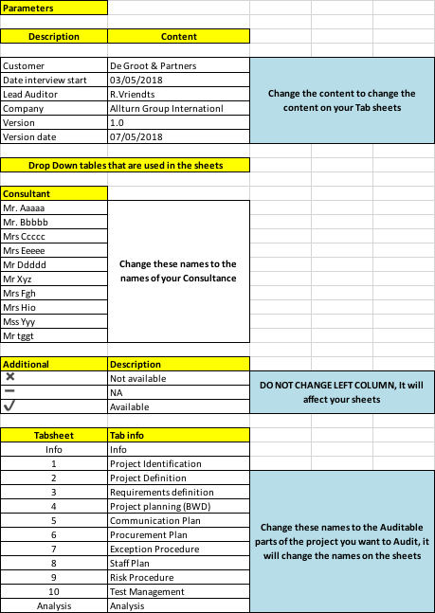

You can change all the information left from the “Blue” Box, except the numbers 1 to 10, these are used in the sheet.

The information that you change has a direct influence on the content of your sheet

In Info Sheet you will see the following

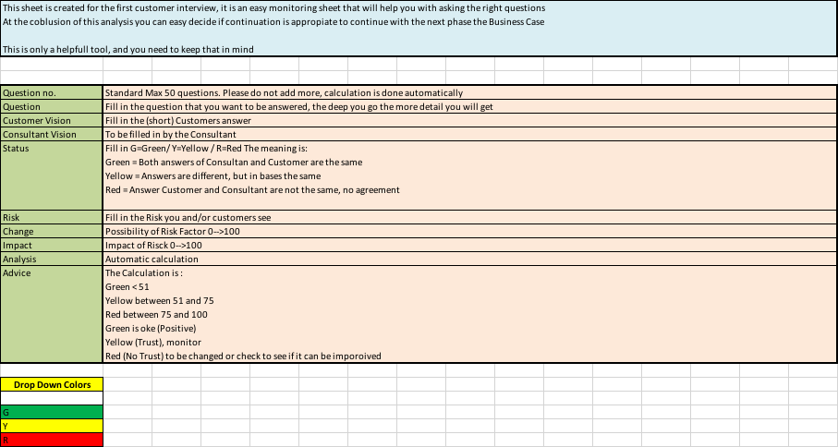

This is just q quick hands-on help sheet, does not do anything, beside the Drop down Colors box, this will be used in the sheet also.

## Date Sheets 1-10

Than we have the numbers 1 to 10, you can see them below in the Tab Sheet name (yellow marked) In this sheet you see a lot of information that I will describe per item.

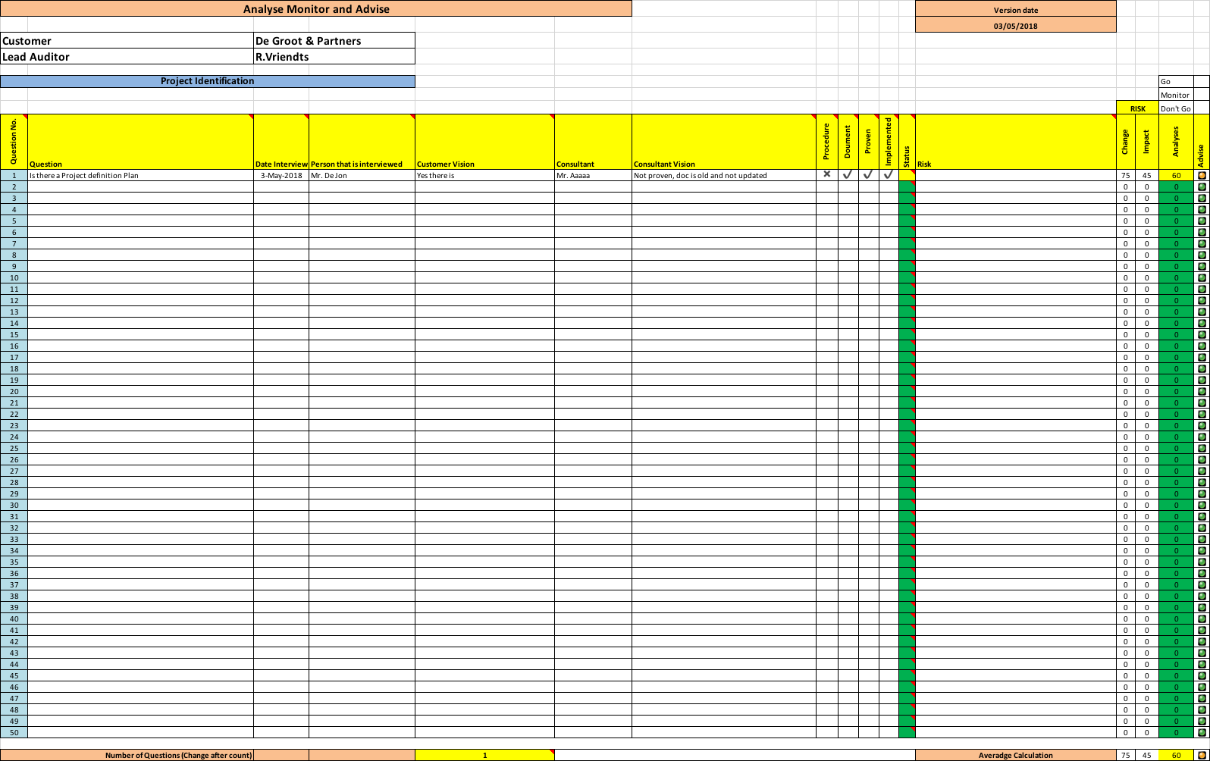Example sheet 1

The name “Customer” is filled with the content of the parameter sheet Content, Name itself is in the box right to it.

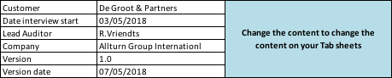

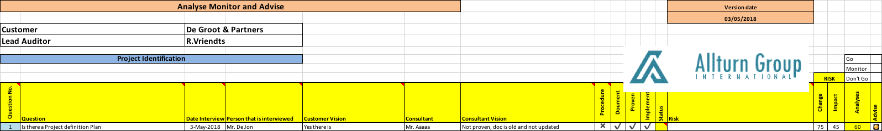



And so you will see different field that are used (follow lines)

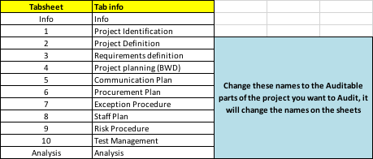

This makes you sheet a lot easier to control, just fill in your own information.

## Data Sheet data part

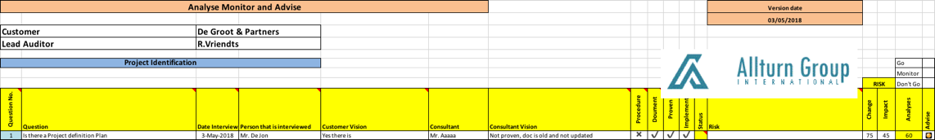

You will see the following information that you can change

Question no. - Not to be changed

Question - Type in the question that you want to be answered

Date Interview - The date the question (Interview) asked

Person that is interviewed - The person that you talked to

Customer Vision - The answer you got after asking the question

Consultant - The name of the Consultant (can be filled in parameter sheet)

Consultant Vision - What do you think after having the answer, what is your vision

Procedure - Here you can use a drop-down box where

X = Not available, - = Not Applicable and V = Available

Document - Here you can use a drop-down box where

X = Not available, - = Not Applicable and V = Available

Proven - Here you can use a drop-down box where

X = Not available, - = Not Applicable and V = Available

Implemented - Here you can use a drop-down box where

X = Not available, - = Not Applicable and V = Available

Procedure:

If there is Procedure available click on the appropriate drop-down choice

Document:

If there are documents available click on the appropriate drop-down choice

Prove:

If you have seen prove of your observation, you can fill in here

Implemented:

If you see proof that it is implemented than you can fill in here

This is the part where you can fill in the various indicators. These indicators are marked Green, Yellow and Red.

It is obvious the Green is Oke and Yellow is Monitor and Red is not Oke.

You can also fill in the Risk Factors, with other words, give a number between 0 and 100 what the Chance is that a risk will occur and also what the Impact is (also between 0-100)

This will calculate the Analysis and will also mark the light on the right side.

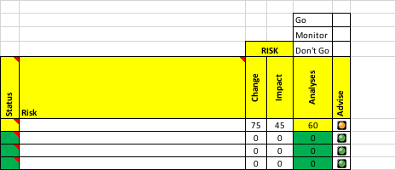

This is the same for every page from 1 to 10.

On every page you can fill in 50 questions or observations.

If you want to add more questions, you need to change the excel sheet, please first investigate how.

Important parameter on every page

On the Bottom you see Number of Questions (Change after count), on the right you see a number, in this case it is “1”, if you fill in more than 1 question, count the number of questions (max 50) and change this number, it is used for the calculation.



## Analysis

All the information regarding the indicators are totalized on the page Analysis.

Here the data is calculated and you can see on the colors what the status is of, for example the project.

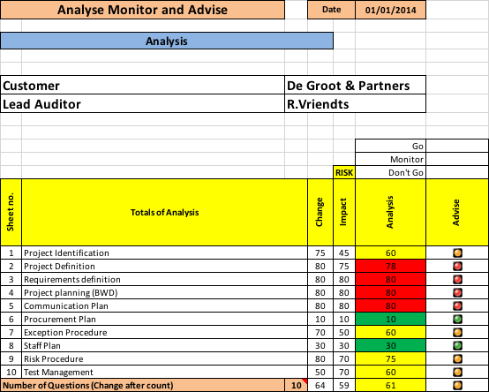

If the majority of the Analysis colors are Red or Yellow, there is definitely something wrong.

## Afterword

This Excel sheet is definitely not rocket science, it was only intended to make life a little bit easier.

It did not take me long to create it, but I use it a lot and it is easy and gives you at least a full overview what was discussed during the Audit.

Sometimes it does not need to be complicated to do the Job.

Thanks and have fun with it,

Thanks to

Rudy Vriendts, Allturn Group International

Please take a look at our website under downloads, you will find a number of handy excel sheets but also “Free” training on Project management including all the handbooks.

<https://www.Allturngroup.com>

Email : [Rudy.Vriendts@allturngroup.com](mailto:Rudy.Vriendts@allturngroup.com)